Creating a SQL Server with Database and Adding Firewall Settings

1. Created a SQl Server with a DataBase

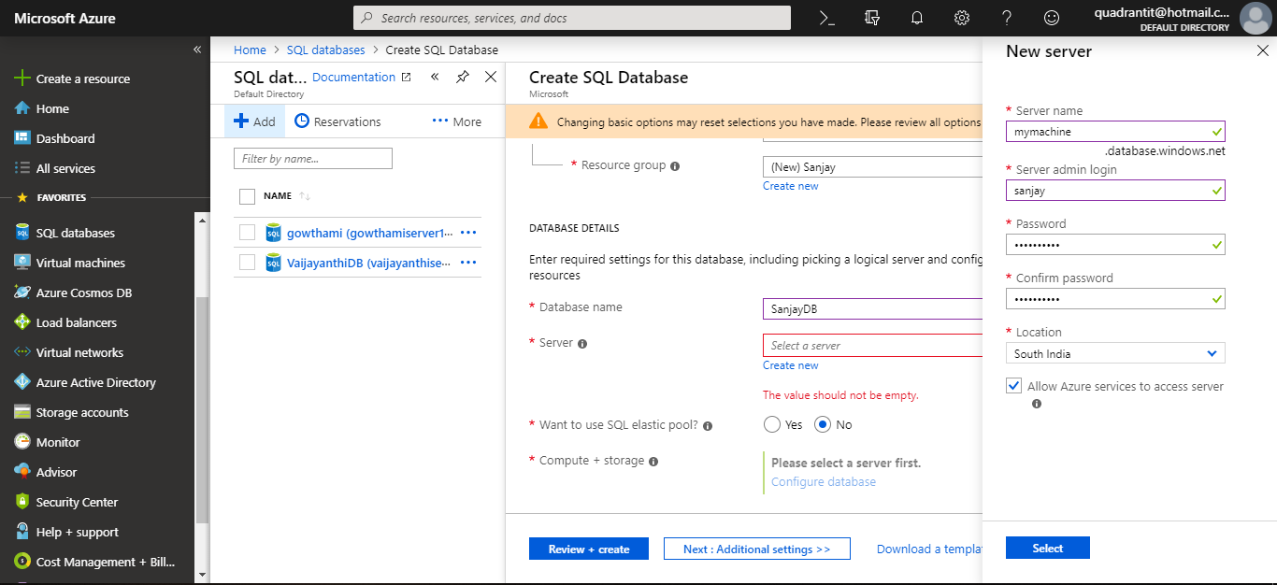

1. Created a SQL Server

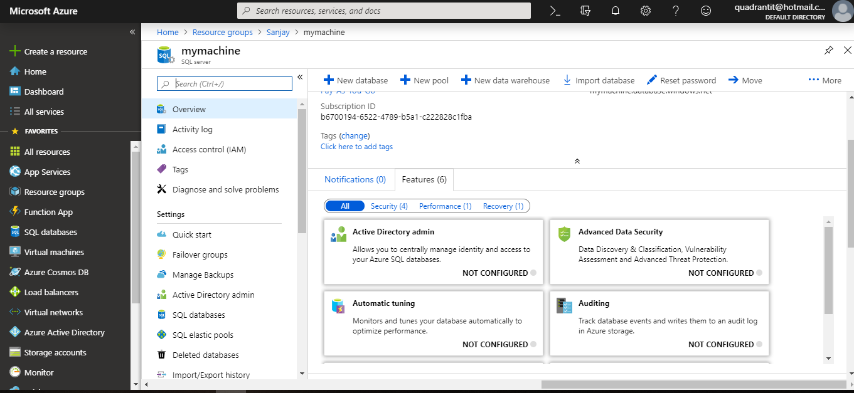

1. Created a Database in SQL Server.

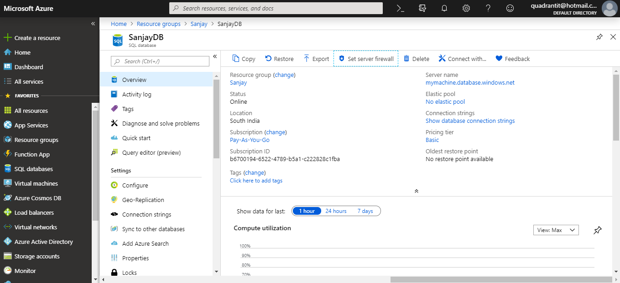

1. Adding Firewall settings to the Database.

